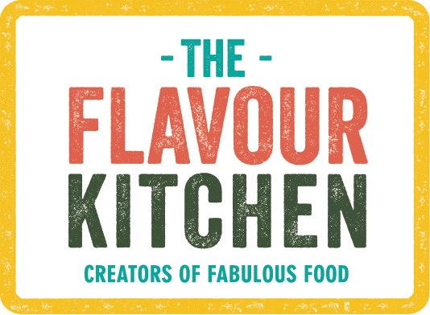

**Cold Lunch Sharing Platters 2024**

**MAINS**

*Meat*

Peppercorn crusted rare sirloin of beef with horseradish creme and slow roast tomatoes (M, Mu)

Harissa Rubbed Rare Sirloin of Beef with Jewelled Couscous (G, Ce, Se, M)

Coronation chicken with Mango Chutney (M, Mu, Ce, E)

Honey and Saffron baked chicken (Ce)

Chicken Shawarma skewers with preserved lemon hummous (Se, M)

Hoisin duck, feta, watermelon and rocket salad with toasted cashews and plum sauce dressing (S, Se, M, N) - NOT HALAL

Curried Scotch eggs with mustard mayo (G, E, M, Mu)- NOT HALAL

Jerk Chicken with Green Pepper and Avocado Dressing

Smoked Chicken, Mango and Avocado Salad - NOT HALAL

*Fish*

Hot Smoked Trout, New Potatoes and Watercress Salad

Hot smoked salmon and dill tarts (F, G, E, M)

Z'atar baked salmon with walnut and yoghurt (N, M, F)

Herbed fish koftes with spiced yoghurt (F, M, G)

*Vegetarian/Vegan*

Spinach, mint and feta borek with chilli-honey dressing (G, M)

Caramelized red onion and goats cheese tarts (G, E M)

Spiced roast cauliflower frittata (V) (M, E)

Roast vegetable tarts with walnut pesto (Vegan) (G, N)

Iman Biyaldi - stuffed aubergine with saffron yoghurt ((V) (or coconut yoghurt for vegan version) (M if not vegan)

Sweetcorn fritters with avocado and tomato salsa (M, E, G)

Red onion and asparagus pesto tart (Vegan) (G)

Sweet Potato Cakes w, Mojo Sauce (Vegan)

**SIDES**

Italian herb new potato salad (Vegan)

Jewelled couscous w, pistachios, almonds, barberries & pomegranate (V) (can be made vegan) (N, G, M if not vegan, Ce)

Persian potato salad with chermoula (Vegan)

Homemade maneesh bread and selection of dips e.g. baba ghanoush (vegan); roasted red pepper and walnut (vegan) and feta, dill and pistachio (G, M, N)

Fattoush salad with fried flat breads, heirloom tomatoes, cucumber and baby gem with sumac and lemon dressing (vegan) (G)

Griddled aubergine, pomegranate, feta and rocket salad (M)

Charred courgette and tenderstem broccoli salad with tahini-honey dressing (Vegan) (Se)

Charred courgette ribbons, feta, pinenut and rocket salad with chilli-lemon dressing (V) (M)

Caesar Salad w, Sourdough Croutons, Bacon and Shaved Pecorini (G, M, E, Mu) (can be made vegetarian)

**CHARCUTERIE & CHEESE PLATTERS**

Mixed or charcuterie or cheese only platters served with relishes, fresh fruit, crackers and bread

(additional charges apply)

**DESSERTS (Choose 2)**

Salted Caramel Brownies (G, E, M)/Vegan Brownies (G)

Lemon Tart w, Raspberry Compote (G, E, M)

New York Cheesecake Bites (G, E, M)

Vegan White Chocolate Cheesecake (G)

Little Lemon Posset Pots (M)

Chocolate Pots (M)

Individual or sharing Berry Palova

Lemon Polenta Cake w, Mascarpone Cream (N, E, M) (can be made vegan)

ALLERGENS:

S - Soy,

Se - Sesame

M - Milk

G - Gluten

F - Fish

Mo - Molluscs

Ce - Celery

C - Crustacean

E - Eggs

Su - Sulphites

Mu - Mustard

N - Nuts

P - Peanuts

Lu - Lupins