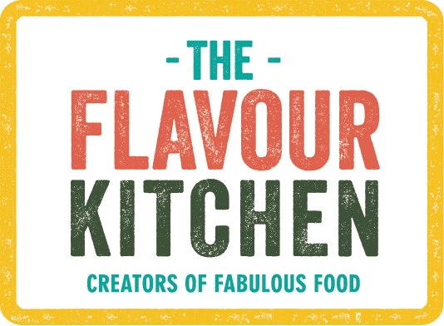

**Breakfast Menus**

***Cold Items (Drop Off)***

Home-made granola with seasonal compote, honey, Greek or Soy yoghurt (vegan), pistachio crumb

Mango compote and Coconut yoghurt chia pots (Vegan)

Overnight Oats with Sesonal Compote (Vegetarian/Vegan)

Charcuterie and cheese board

Fresh fruit skewers with passionfruit compote and Greek or Coconut Yoghurt

Home-made Muffins/Banana Bread (gluten free and vegan version available)

Smoked Salmon & Cream Cheese Bagels

Breakfast Frittata (Chorizo and Spinach or Red Pepper & Spinach)

Selection of Viennoiserie and patisserie (including vegan patisserie)

***Hot Dishes***

Breakfast Rolls with Choice of 2 Fillings (Bacon, Fried Egg, Sausage, Veggie Sausage, Portobello/vegan cheese/spinach, Mushroom Omelette)

Full English Breakfast Buffet - with Local Pork sausages, crispy bacon, fried eggs, portobello mushrooms and breakfast buns (vegetarian version available with vegetarian sausages)

Vegan English Breakfast with Vegan Sausages, Vegan Bacon, Portobello Mushrooms, Roast Tomatoes and Breakfast Buns

Smashed Avocado on Sourdough Toast with Balsamic slow roasted tomatoes (Vegan) or poached egg and crispy parma ham or poached egg and Smoked Salmon

***Drinks***

Gourmet Tea & Coffee

Fresh Juices

Smoothies